China

## Political Stability Estimate Data

The data set shows the political stability estimate of the country each year.

## # A tibble: 19 x 5  
## country iso3c date stability stabilityCategory4   
## <chr> <chr> <dbl> <dbl> <chr>   
## 1 China CHN 1996 -0.0960 moderately unstable  
## 2 China CHN 1998 -0.391 moderately unstable  
## 3 China CHN 2000 -0.209 moderately unstable  
## 4 China CHN 2002 -0.327 moderately unstable  
## 5 China CHN 2003 -0.564 moderately unstable  
## 6 China CHN 2004 -0.390 moderately unstable  
## 7 China CHN 2005 -0.502 moderately unstable  
## 8 China CHN 2006 -0.540 moderately unstable  
## 9 China CHN 2007 -0.499 moderately unstable  
## 10 China CHN 2008 -0.491 moderately unstable  
## 11 China CHN 2009 -0.449 moderately unstable  
## 12 China CHN 2010 -0.657 moderately unstable  
## 13 China CHN 2011 -0.602 moderately unstable  
## 14 China CHN 2012 -0.539 moderately unstable  
## 15 China CHN 2013 -0.544 moderately unstable  
## 16 China CHN 2014 -0.523 moderately unstable  
## 17 China CHN 2015 -0.550 moderately unstable  
## 18 China CHN 2016 -0.499 moderately unstable  
## 19 China CHN 2017 -0.251 moderately unstable

## Political Stability Estimate Plot

The plot shows the trends of stabilization and destabilization for the each country.

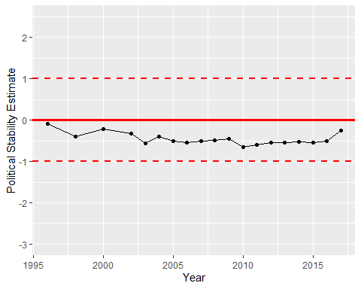

Political Stability Trend